PHTRP Cohort 004 – Prophage Analysis Practical Assignment Title: Identifying Prophage Regions Using NCBI and ProkSee

Scenario
You have joined a microbiology laboratory investigating bacterial genomes. Your supervisor has asked you to check whether one bacterial genome contains integrated bacteriophages (prophages). Use NCBI to retrieve the genome and ProkSee (PHASTEST) to identify potential prophage regions.

Instructions

- Search for Escherichia coli K-12 MG1655 in the NCBI Genome database.

- Filter for Complete genomes and open the reference genome.

- Record the chromosome accession number (NC_000913.3).

- Open ProkSee, create a new map, and run the PHASTEST tool within it

- Answer the questions below.

Questions

- How many prophage regions were identified? 5

- How many of the prophage regions were classified as Intact? 2

- Select one intact prophage and record the following:

  - Region number -2
  - Coordinates -1198640-1216671
  - Length – 18kb

- From the Details tab, identify three phage-associated genes found within your selected prophage.

For each gene, report:
  - - Gene name
PP_00525;integrase;phage;-;PHAGE_Shigel_Stx_NC _029120
  - Function – intergrase –site specific recombinase
- E-value – 0

  - Gene name - PP_00529;IS3 transposase B;phage;-;PROPHAGE_Escher_MG1655
  - Function - transposase involved in transposition
  - E-value - 0

  - Gene name - PP_00527;Ren protein;phage;-;PHAGE_Entero_SfI_NC_027339
  - Function- DNA replication initiation.
  - E-value - 1.39e-14

- In your own words, explain why an integrase is considered strong evidence that a region is a prophage.
(Approximately 100 words.)
An integrase is considered strong evidence that a region is a prophage because integrase is the enzyme that allows a bacteriophage to insert its DNA into the bacterial chromosome. This integration step is a characteristic of the lysogenic cycle, where the phage genome becomes a prophage and is maintained within the bacterial genome. Therefore, if a genomic region contains an integrase gene, it suggests that the DNA was likely integrated into the host chromosome by a temperate phage. Integrase is commonly found at the boundaries of prophage regions and is often associated with attachment (att) sites, which are used for integration and later excision.
Therefore, the presence of an integrase strongly indicates that the region is phage-derived and capable of chromosomal integration, making it strong evidence that the region is a prophage rather than an unrelated segment of bacterial DNA

- Explain the meaning of the E-value for one of the genes you reported.

The E-value (expectation value) indicates the likelihood that the similarity between the gene sequence and a database sequence occurred by chance. It helps determine how significant a BLAST match is.The smaller the E-value, the stronger the evidence that the sequences are genuinely related. An E-value close to 0.0 represents an extremely strong match and provides high confidence in the predicted gene function.

- Upload one screenshot showing your selected prophage region on the genome map.

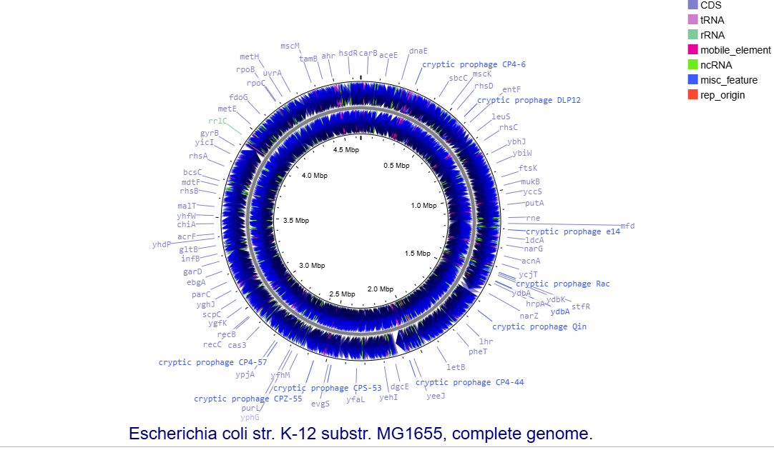

GitHub Submission

Create a public GitHub repository named 'PHTRP_Cohort004_Prophage Analysis'. Upload:
- README.md (A short summary of what you did)

- assignment.pdf or assignment.docx

- Screenshot/PNG of the genome map

Submit the GitHub repository link to the Google Classroom Assignment Box

Resources on Learning Github: https://www.youtube.com/watch?v=r8jQ9hVA2qs&list=PL0lo9MOBetEFcp4SCWinBdp ml9B2U25-f
https://os.ecci.ucr.ac.cr/ci0114/git/progit.pdf

